**CSCI 3260 Group 5 Report**

Xu Minxuan, 1155014330

Zhou Zhihao, 1155014412

2016-04-17

**Moving Objects:**

* Car (Zhou)
  + random acceleration and deceleration behavior
  + replace texture and car model

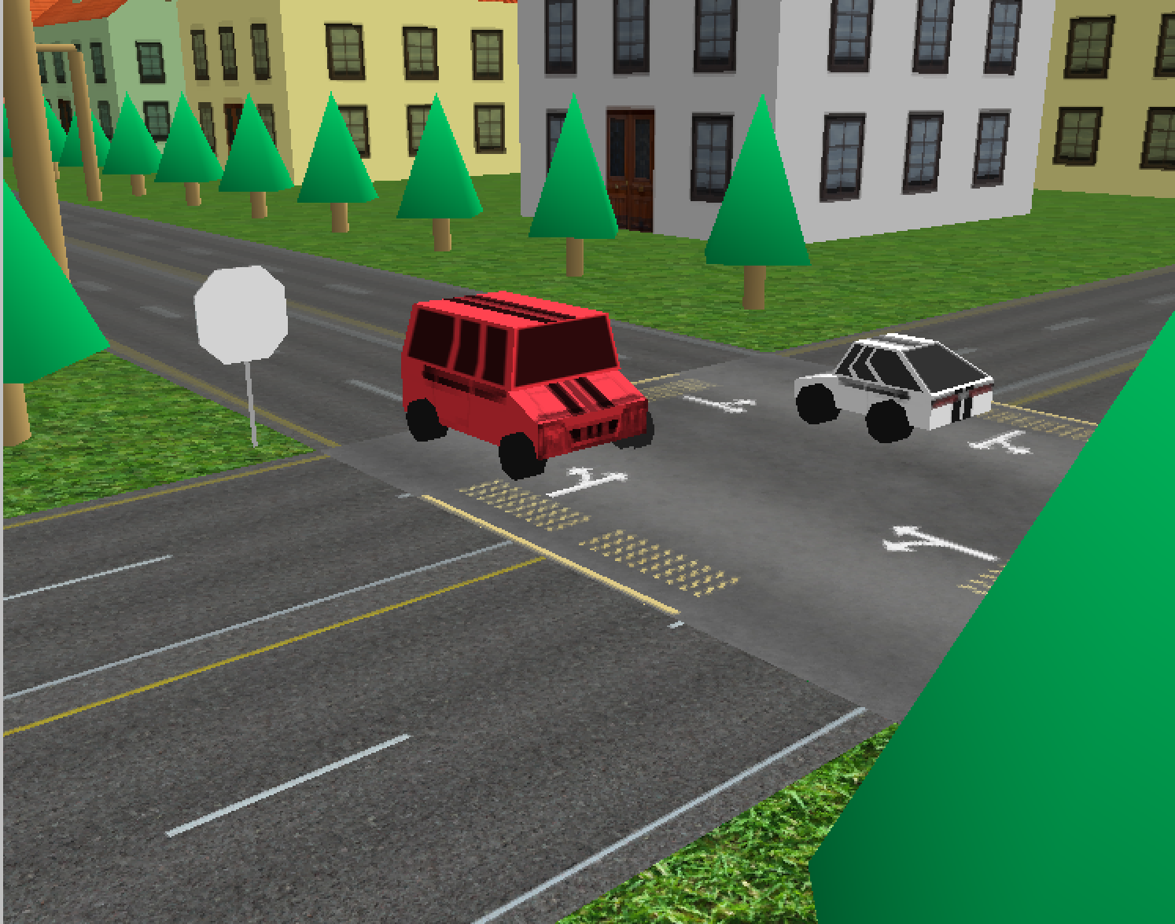

* Hot balloon (Xu)
  + floating behavior
  + curved surface (advanced feature )

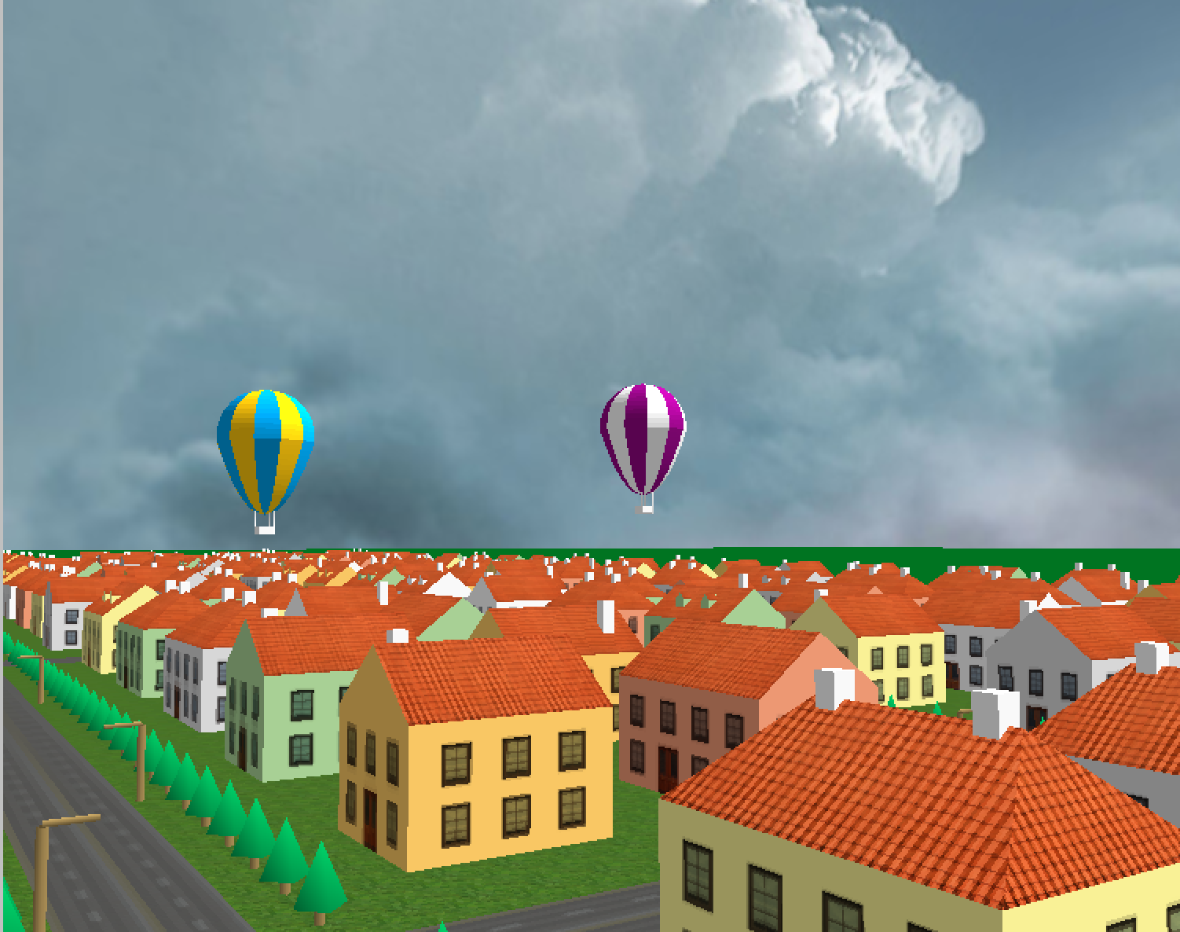

**Scenarios**

* Alexander Nevsky Church (Xu)

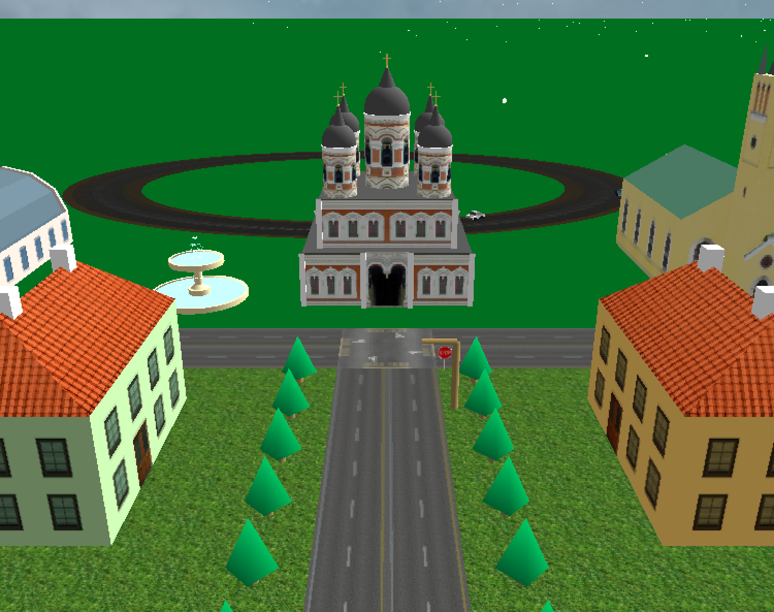

* St.Olav Church (Xu)

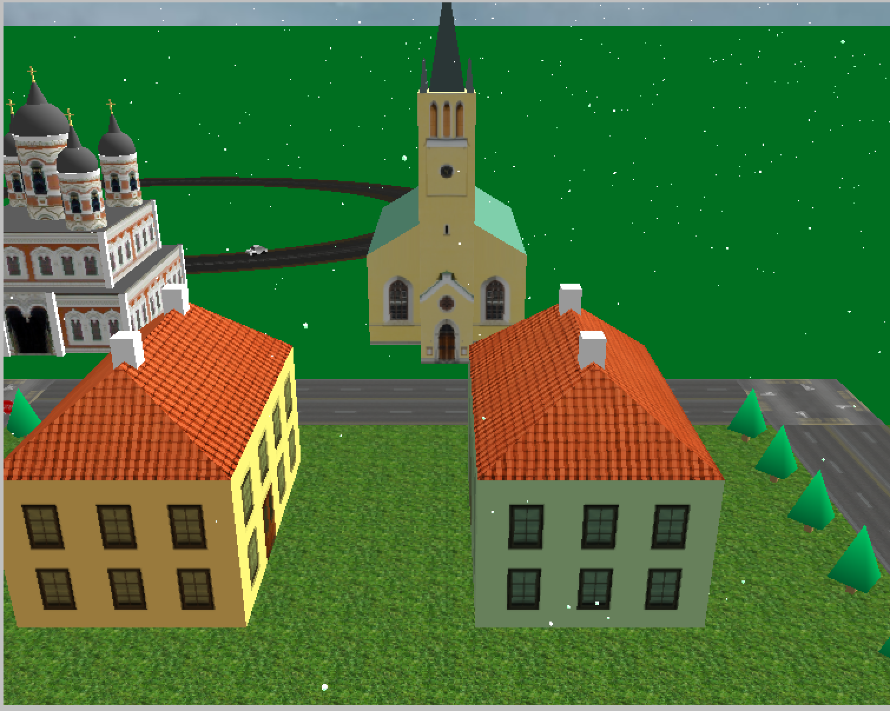

* Medieval Gate (Xu)

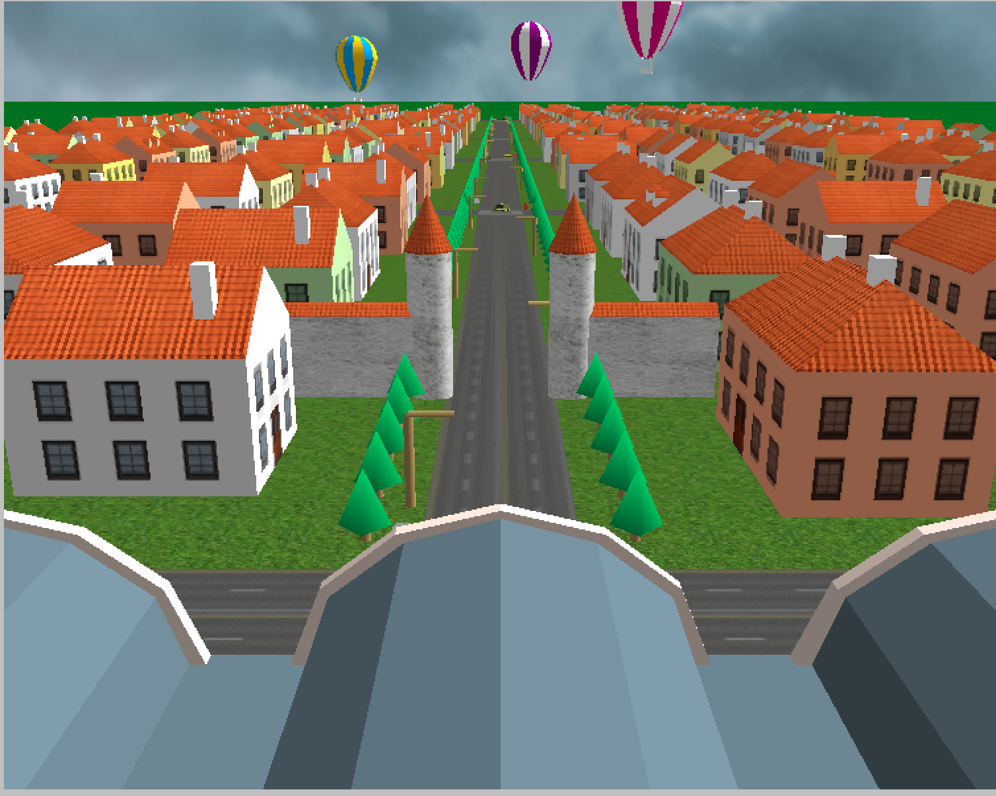

* TV Tower (Xu)
  + Changes with time

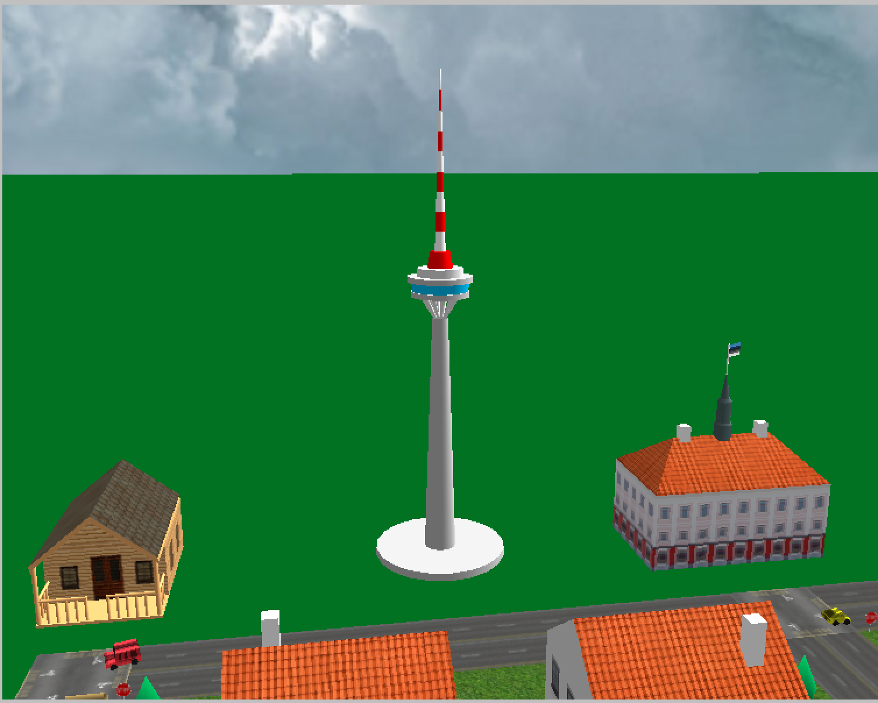

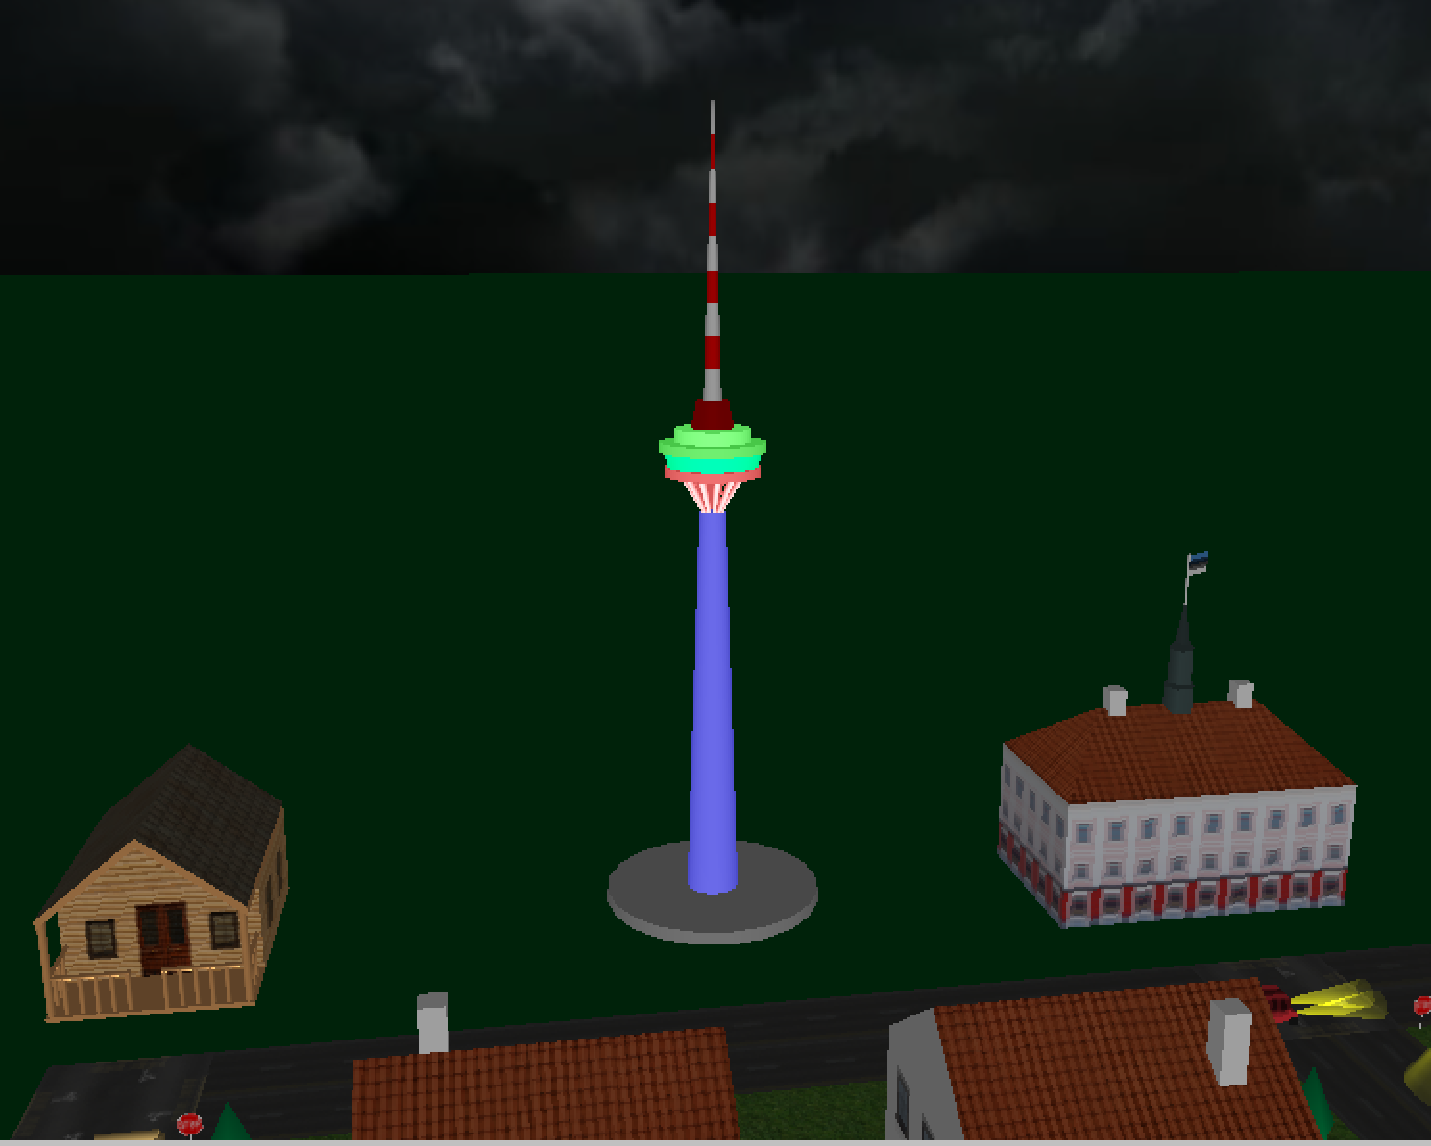

* Central market (Xu)

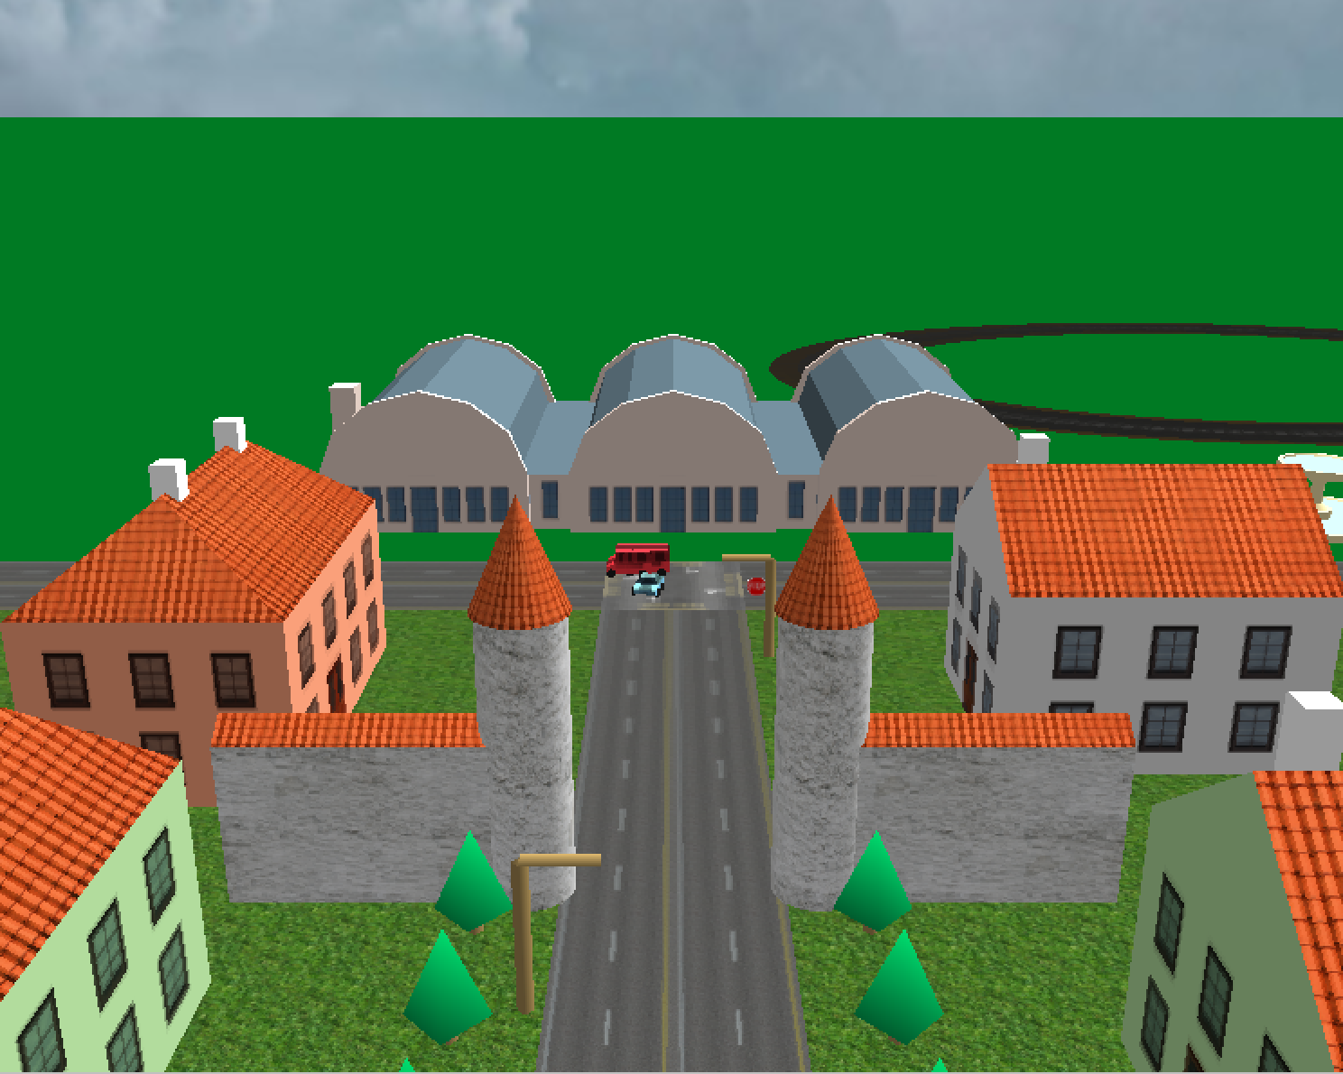

* Town Hall (Xu)

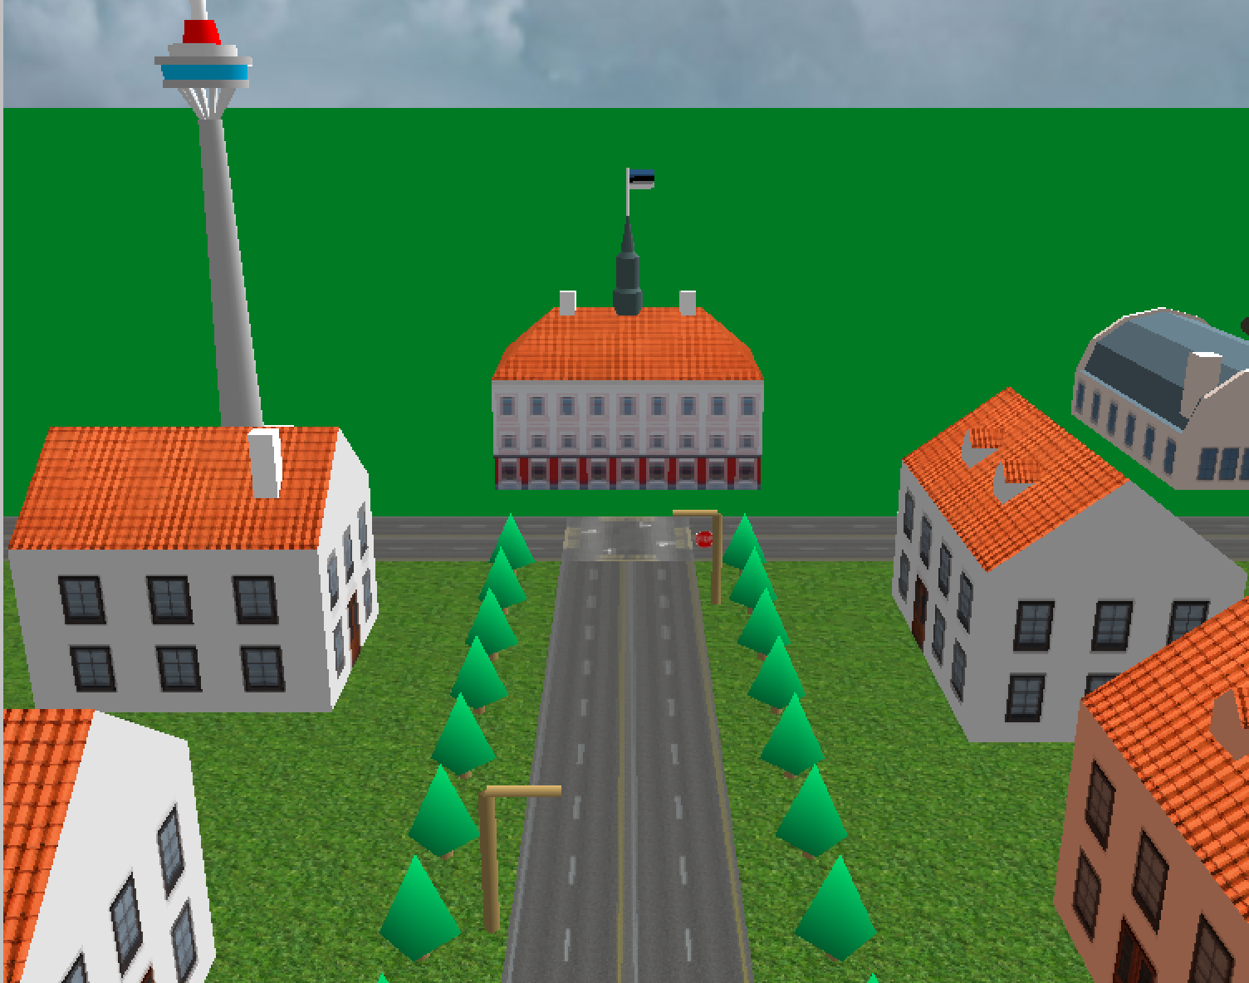

* Sauna House (Xu)
  + Multi-texturing (advanced feature)

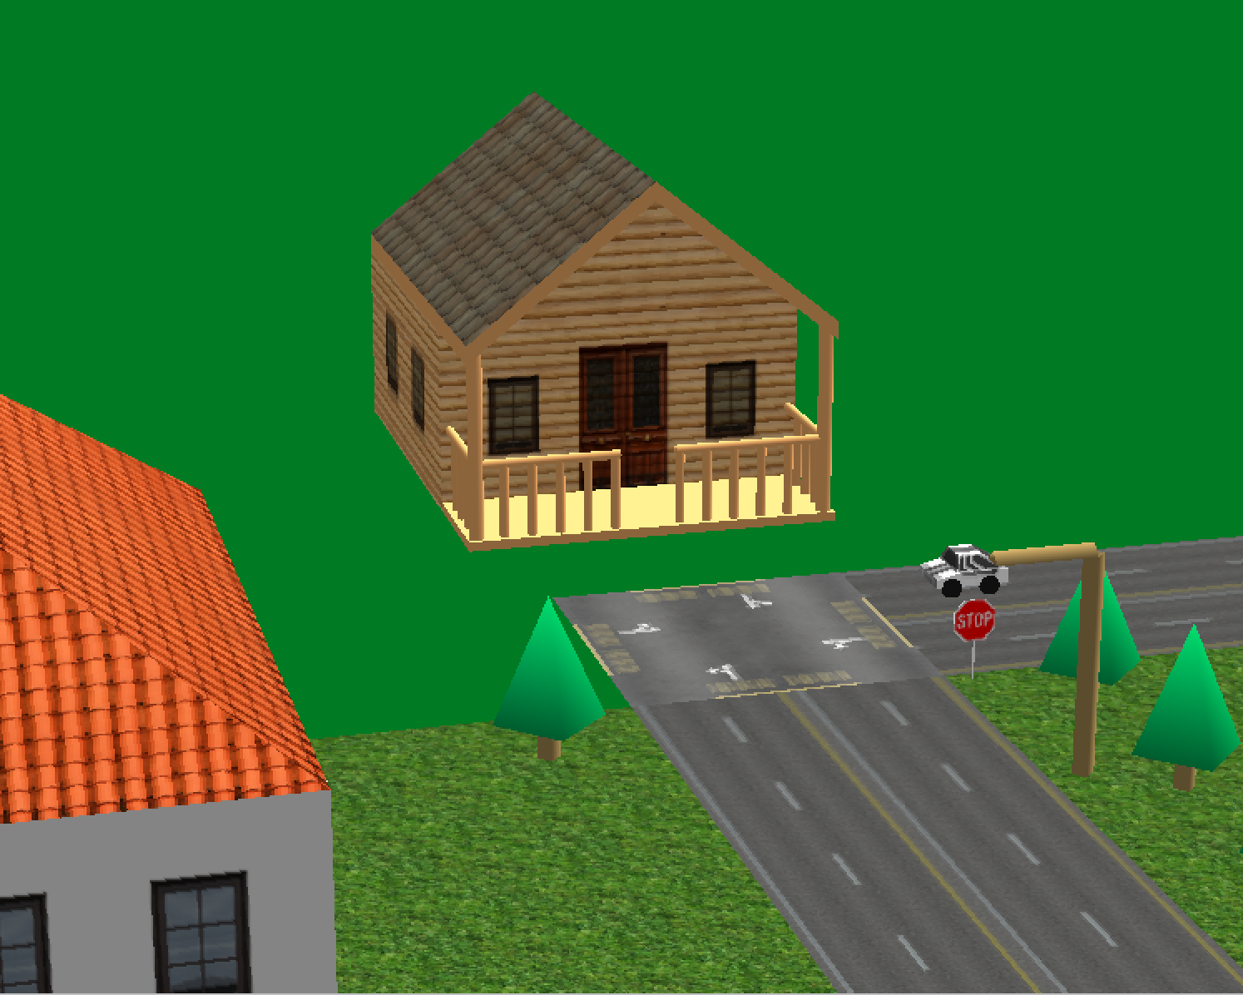

* Fountain (Zhou)
  + Particle system (advanced feature)

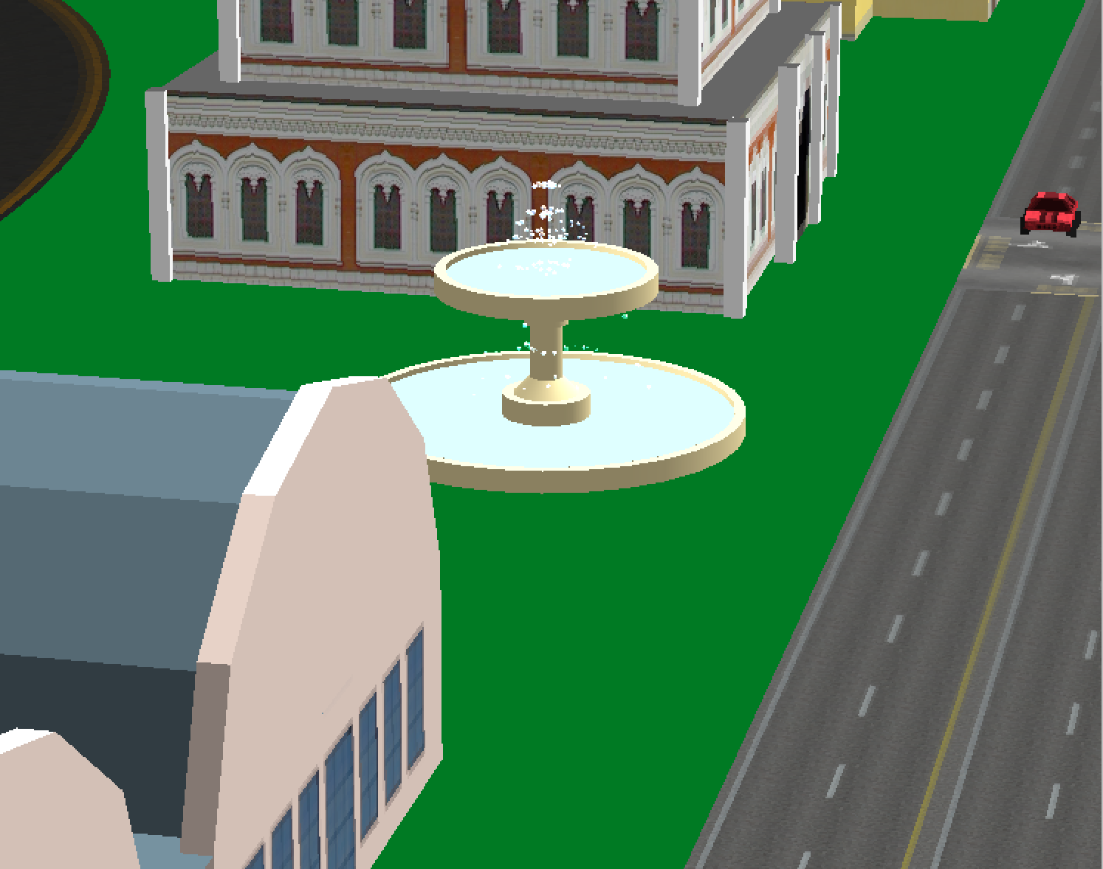

* Racing Track (Zhou)

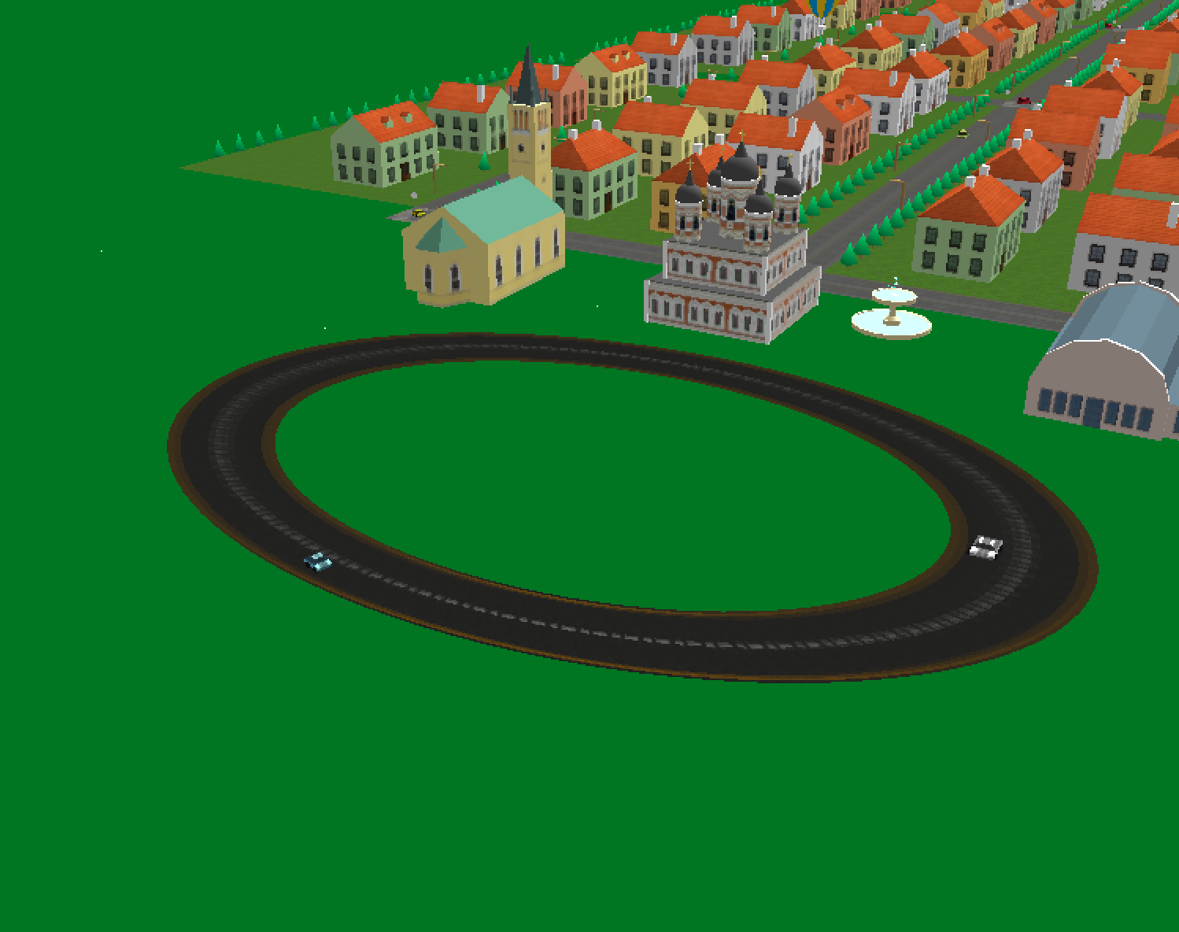

* Skybox (Zhou)
  + Changes with time

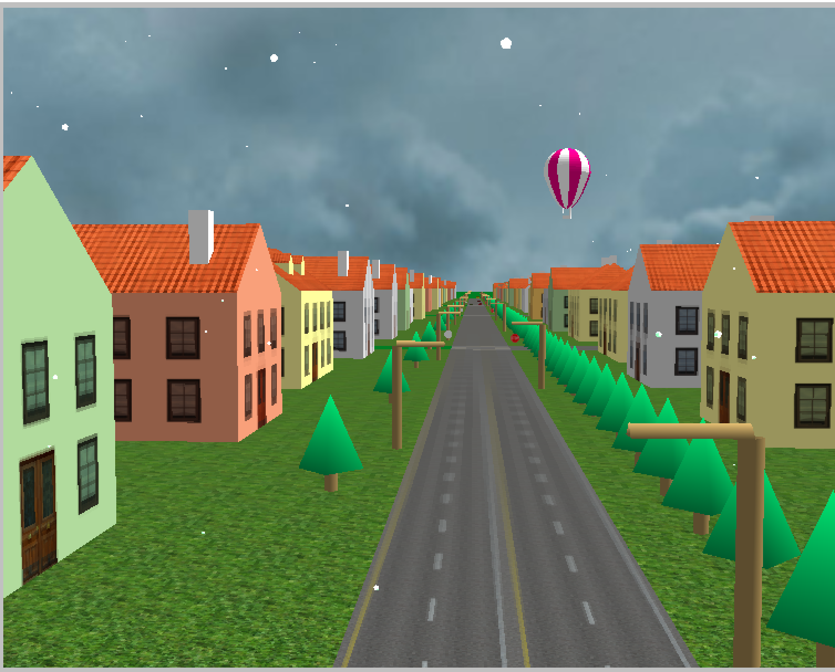

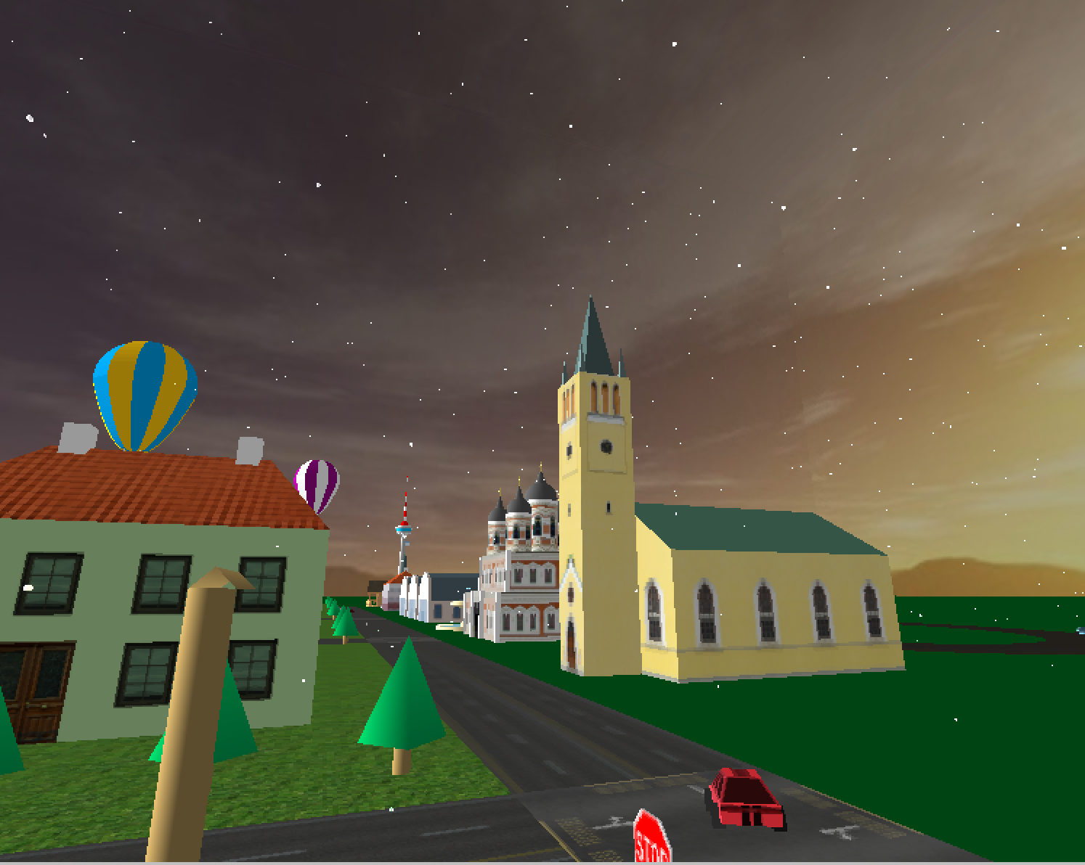

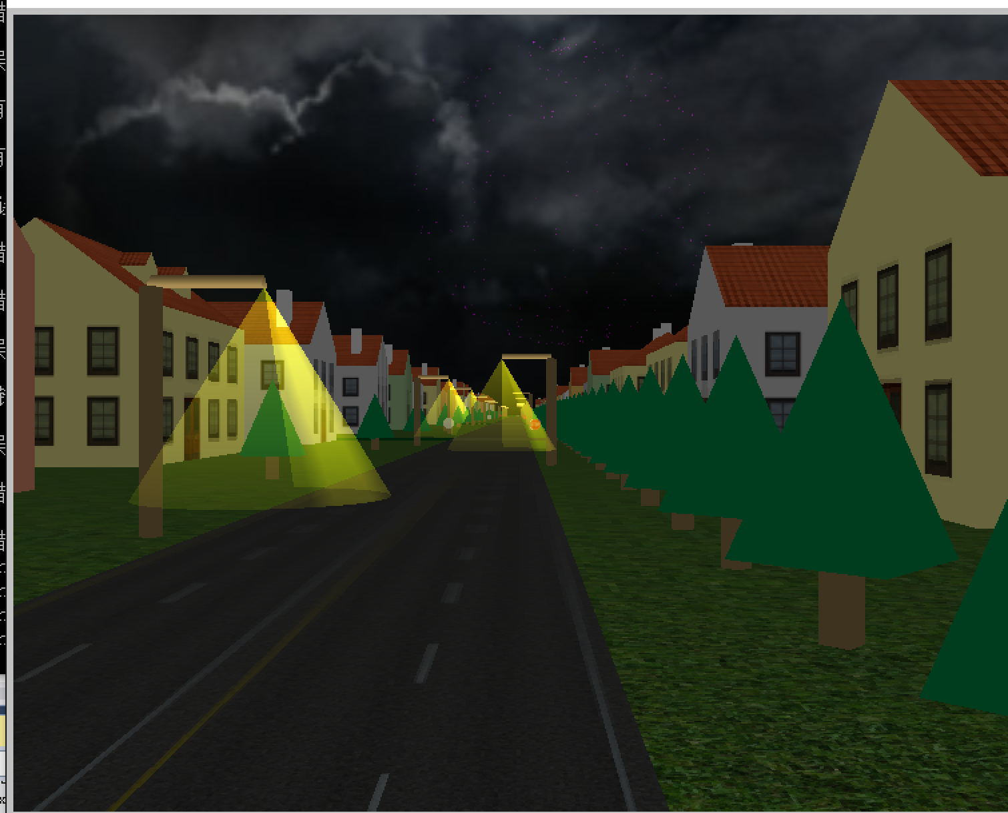

* Fireworks (Zhou)
  + Particle system (advance feature)

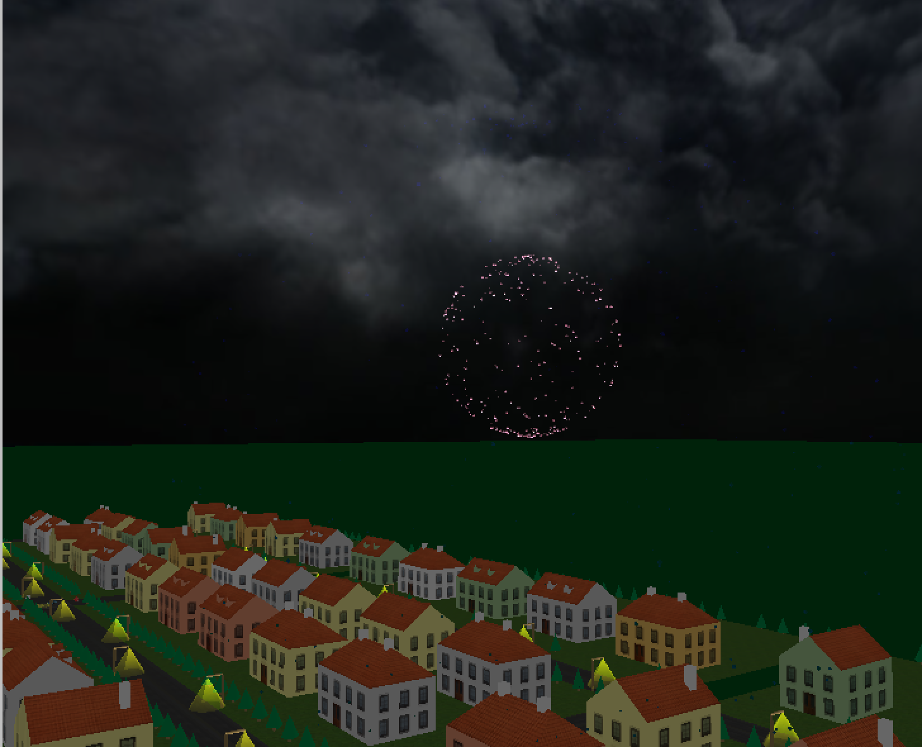

* Snow (Zhou)
  + Particle system (advance feature)

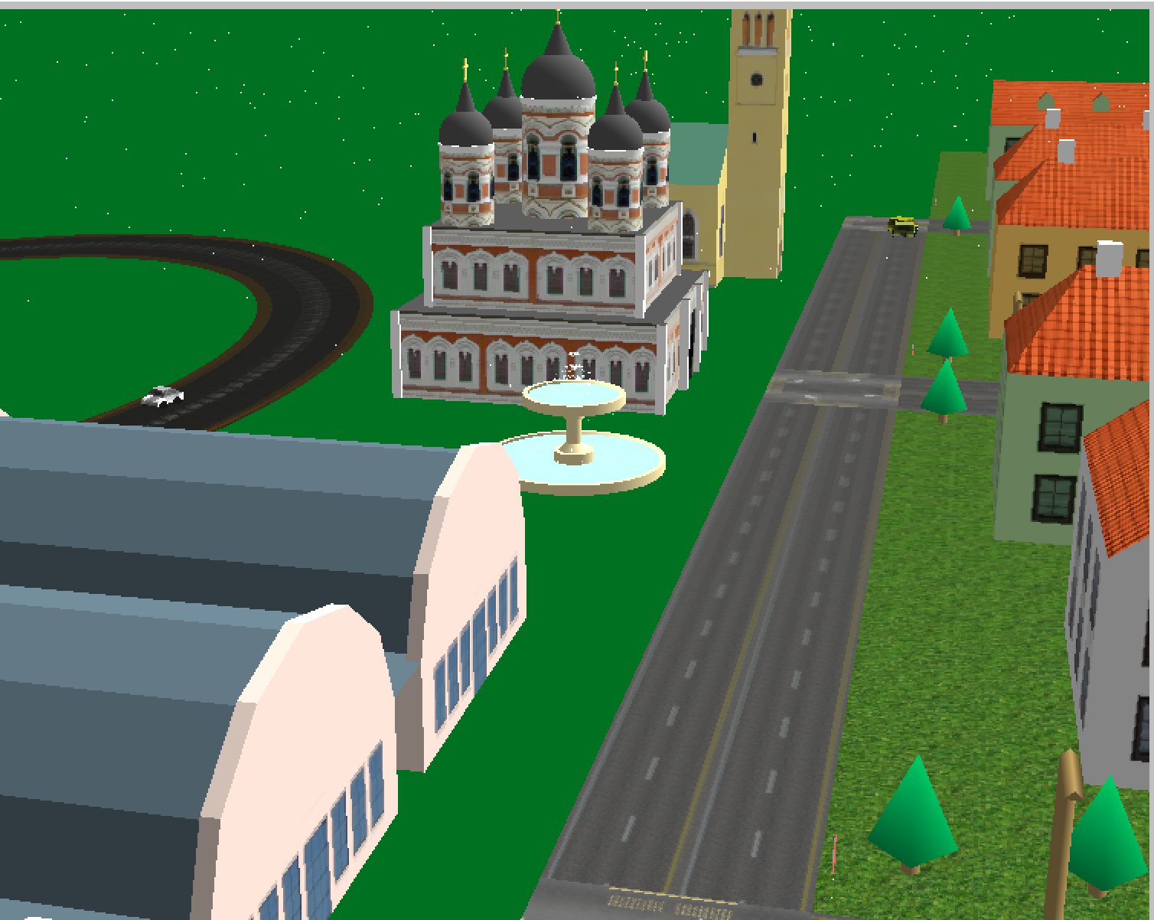

* House, roads, intersection and grass (Xu)
  + New house model and various new textures

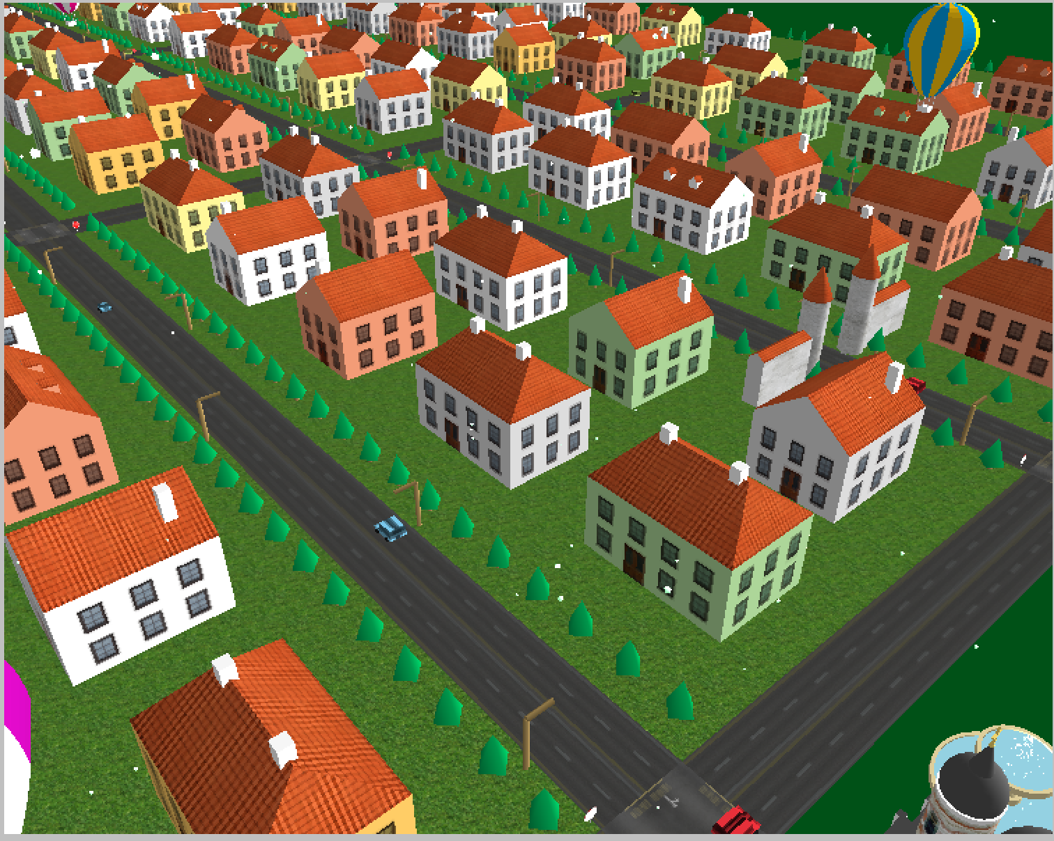

* Selected Views

